# 磁性液体密封矩形极齿参数的优化研究*

王 璐1 张志力1 李德才1, 2

(1. 北京交通大学机械电子与控制工程学院 北京 100044；

2. 清华大学摩擦学国家重点实验室 北京 100084)

摘要：为满足某些重要应用场合中对磁性液体密封装置小型化、轻量化或相同密封尺寸下提高耐压能力的特殊要求，本文使用MATLAB与COMSOL联合仿真分析的实验方法，进行了大量建模及仿真实验分析，研究了不同极靴长度(*Lp*)、密封间隙大小(*Lg*)下矩形极齿结构参数对装置耐压能力的影响以及设计参数间的耦合作用。研究结果解释了齿高(*Lh*)、齿宽(*Lt*)和槽宽(*Ls*)对磁性液体密封装置理论耐压能力的影响，并给出了适用性更广的极齿结构参数设计公式。

关键词：磁性液体密封；耐压能力；参数优化

中图分类号：TB42

**Research on Parameters Optimization of Rectangular Pole Teeth for Magnetic Fluid Seal**

WANG Lu1, ZHANG Zhili1 Li Decai1, 2

(1. School of Mechanical, Electronic and Control Engineering, Beijing Jiaotong University, Beijing 100044;

2. State Key Laboratory of Tribology, Tsinghua University, Beijing 100084)

**Abstract：**In order to meet the special requirements of miniaturization and lightness of magnetic fluid seal device in some important applications or to improve the seal capacity under the same sealing size, a large number of modeling and simulation experiments were conducted in this paper by using the co-simulation analysis experimental method of MATLAB and COMSOL. The influence of the structure parameters of rectangular pole teeth on the seal capacity of the device under different pole lengths(*Lp*) and seal gaps(*Lg*) and the coupling effects between design parameters were studied. The results explain the influence of tooth height (*Lh*), tooth width (*Lt*) and groove width (*Ls*) on the th eoretical seal capacity of magnetic fluid seal device, and give a more widely applicable design formula of pole teeth structure parameters.

**Key words**：Magnetic fluid seal；Seal capacity；Parameter optimization

Introduction[1]*[2]

密封领域是磁性液体应用最早的领域，也是目前应用最广泛、最成熟的领域，包括真空密封、气体密封、液体密封[1,2]。

Sealing is the earliest field of application of magnetic fluid, which can be divided into vacuum seal, gas seal and liquid seal. Sealing is also the most widely used and mature field at present.

相比于传统密封方案，磁性液体密封有诸多优点[3]：1）零泄漏(在通常情况下气体泄漏少于10-11(Pa·m3)/s便可以认定为零泄漏)；2）可靠性高；3）寿命长；4）无污染；5）最优扭矩传递；6）低粘性摩擦；7）可恢复等，受到广泛关注。

Compared with other sealing methods, due to its zero leakage (usually considered as zero leakage if the gas leakage is less than 10-11 (pa m3)/s), high reliability, long life, no pollution, optimal torque transmission, low viscous friction, recoverability, magnetic fluid seal has attracted more attention.

图1所示为磁性液体的单磁回路-多级密封形式，即由永磁体作为磁源产生磁场，通过在极靴或密封轴上加工多个极齿实现多级密封。

The magnetic fluid single magnetic circuit-the multi-stage seal schematic diagram is shown in figure 1, and the permanent magnet is used as the magnetic source to produce the magnetic field. A multi-stage seal is achieved by machining a plurality of pole teeth on the pole shoe or sealing shaft.

利用磁性液体的流动性及对磁场的响应特性，在密封间隙中注入磁性液体，其将吸附于相应部位以形成一个个液体“O”型圈，组成由永磁体-极靴-密封轴-磁性液体/密封间隙的完整磁回路。

Due to the fluidity and responsiveness to the magnetic field, the magnetic liquid can be adsorbed on the corresponding part to form a liquid ‘O’ ring after being added between the pole shoe and shaft. The whole magnetic circuit of ‘Permanent Magnet - Pole Shoe - Sealing Shaft - Magnetic Fluid / Sealing Gap’ is formed.

极齿具有聚磁作用，使得密封间隙内形成非均匀磁场，当磁性液体受到压力差时，其将在密封间隙的非均匀磁场中变形、移动并产生对抗压力差的力，从而起到密封的作用。因此在密封设计和加工过程中，极齿参数对耐压能力起着重要影响。磁性液体可以在极齿与轴之间所形成的非均匀磁场下变形、流动。因此达到了密封作用。在对密封的设计和制造的过程中，极齿的参数对耐压能力起着重要影响。

The magnetic fluid can deform and flow under the non-uniform magnetic field formed between the pole teeth and the shaft. The sealing effect is achieved. The parameters of pole teeth play an key role in the pressure resistance in the process of seal design and manufacture.

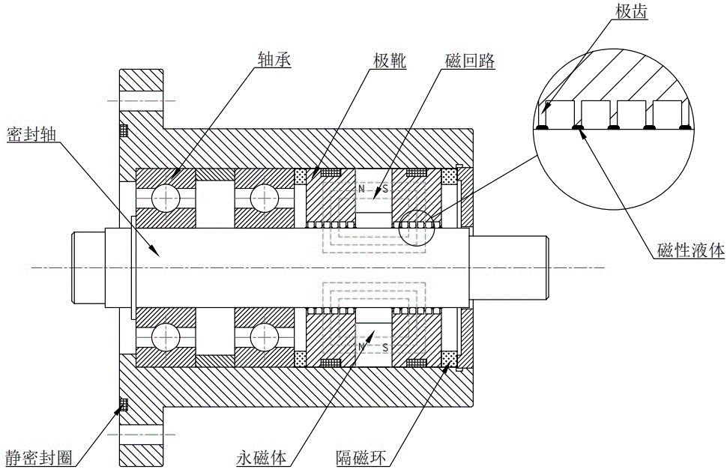

图1 磁性液体单磁回路-多级密封原理图

Fig. 1 Schematic diagram of magnetic fluid single magnetic circuit multi-stage sealing

矩形极齿因具有耐压能力大、双向耐压相同、加工工艺简单等特点而被大量使用[4]。

矩形极齿结构参数包括齿高(*Lh*)、齿宽(*Lt*)和槽宽(*Ls*)，密封间隙(*Lg*)则是磁回路中磁阻的主要来源。

Rectangular pole teeth are widely used because of their strong pressure resistance, the same two-way pressure resistance and simple processing technology. Tooth height (Lh), tooth width (Lt) and groove width (Ls) are the structural parameters of rectangular pole teeth. Sealing gap (Lg) is an important parameter to determine the magnetoresistance in the magnetic circuit.

Walowit与Pinkus[5]建立了磁性液体密封装置的磁路参数、流体性质与其耐压能力之间的关系，

Walowit and Pinkus [5] found the relationship among magnetic circuit parameters, fluid properties and pressure resistance of magnetic fluid sealing devices.

其研究表明恒强度线和恒压线是磁性液体潜在界面的较好近似，推导出齿宽为密封间隙的2倍(*Lt=2Lg*)、槽宽为密封间隙的3倍(*Ls=3Lg*)时，装置可获得最大耐压能力的结论。The constant strength curve and the constant pressure curve of the potential interface of the magnetic fluid have a similar trend. The maximum pressure resistance of the device can be obtained when the tooth width is twice the seal gap (Lt=2Lg) and the groove width is three times the sealing gap (Ls=3Lg).

Pinkus[6]在间隙为*0.254mm*，齿宽为*2.54mm*，槽宽为*2.54mm*进行了单级密封到五级密封的密封实验，实验结果表明，随着密封级数增长，装置耐压能力得到增长，其中极齿平均耐压能力在四级密封时达到最大值。Pinkus [6] carried out sealing experiments from single-stage seal to five-stage seal with 0.254mm gap, 2.54mm tooth width and 2.54mm groove width. The results show that the pressure resistance of device would increase with the increase of sealing stages, and the average pressure resistance of polar teeth reaches the maximum value in four-stage sealing.

许永兴等[7]使用任意三角形网格划分的有限元法对单级齿情况进行仿真优化得到*Lt*的选取范围为*(4~6)Lg*，对三极齿情况进行仿真优化得到*Ls*的选取范围为*(25~30)Lg*，*Lh*的选取范围为*(20~30)Lg。*

Xu [7] simulated and optimized the single pole tooth by using the finite element method of random triangular meshing and obtained that the selection range of Lt is (4~6) Lg. He also simulated and optimized the three pole tooth, and obtained that the range of Ls is (25~30) Lg, the range of Lh is (20~30) Lg.

张世伟等[8]研究了极齿对应密封间隙内的磁场计算方法，引入了极靴齿型结构的最大相对磁导率差和几何磁导用以分析齿型参数对密封装置的耐压影响，认为应选择*Lt=(3~5)Lg*，*Ls=(20~30)Lg*，*Lh=(0.8~1)Ls*。

Zhang [8] studied the calculation method of magnetic field in the corresponding sealing gap of pole teeth. The maximum relative permeability difference and geometric magnetic conductance of the pole boot tooth structure are introduced to analyze the influence of tooth profile parameters on the pressure resistance of the sealing device. The relationships among slot width, gap and tooth width were obtained: Lt= (3~5) Lg, Ls= (20~30) Lg, Lh= (0.8~1) Ls.

李德才等[9]采用*Lt=5Lg*，*Ls=20Lg*，*Lh=1.25Ls*参数比例，在*Lg=0.1mm*时进行了干式罗茨真空泵的密封设计，并进行了仿真和实验验证，装置总体密封效果好。According to the size proportion of Lt=5 Lg, Ls=20 Lg, Lh=1.25 Ls, Li [9] designed the sealing of dry Roots vacuum pump in Lg=0.1 mm. The simulation and experimental results show that the overall sealing effect of the device is ideal.

赵国伟等[10]通过单因素仿真实验分别分析了密封间隙、极齿宽度、极齿高度、齿槽宽度、永磁体外径、永磁体内径、永磁体厚度、齿数对强磁和弱磁结构的磁性液体密封的影响规律，并对某特定结构优化，在保证性能的情况下降低了密封装置50%以上的质量和体积。Zhao [10] studied the sealing gap, tooth width, tooth height, groove width, outer diameter of permanent magnet, inner diameter of permanent magnet, thickness of permanent magnet and the number of teeth on the magnetic fluid sealing of strong magnetic and weak magnetic structure using single factor simulation experiments. The structure of sealing device is optimized, and the mass and volume of the sealing device are reduced by 50% under the condition of ensuring performance.

赵国伟等[11]在此基础上给出了优化设计方法并进行了实验研究。

Furthermore, Zhao [11] optimized the design method and carried out experiments on this basis.

程杰等[12]使用单因素仿真和实验，分析了五级对称密封中磁极角、极齿高度、极齿宽度和极齿槽宽的影响。Cheng[12] conducted single factor simulation and experiment to analyze the effects of magnetic pole angle, tooth height, tooth width and groove width in five stage symmetrical sealing.

1. * 国家自然科学基金资助项目(51927810)。20220205收到初稿，20220305收到修改稿
2.